No easy gig: China’s push to better protect platform workers faces hurdles

China's proposed rules aim to improve pay, rest and working conditions for tens of millions of gig workers, but analysts warn that financial pressures, differing work arrangements and enforcement challenges could limit their impact.

CNA Melody Chan

19 Oct 2026

https://www.channelnewsasia.com/east-asia/china-gig-workers-draft-rules-protection-6459661

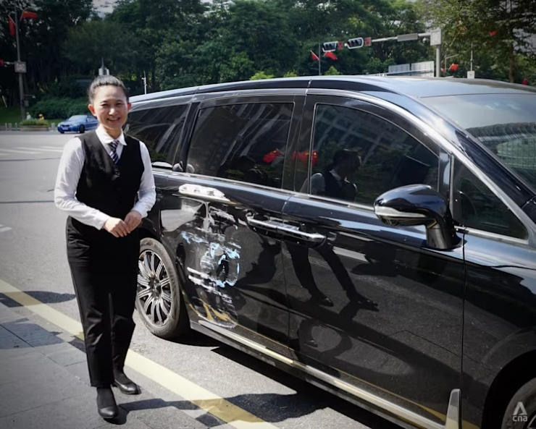
Didi driver Chen, 43, stands beside her scratched car in Shenzhen on Oct 12, 2026. (Photo: CNA/Melody Chan)

SHENZHEN: When ride-hailing driver Chen scratched her car, she decided to take the day off to get it repaired rather than risk driving in a poor state of mind.

But for the 43-year-old, staying off the road comes at a cost.

"When we rest, we don't earn," said Chen, who asked to be identified only by her surname.

She typically works at least 12 hours a day as a driver for Chinese ride-hailing platform Didi in Shenzhen, taking home around 10,000 yuan (US$1,400) a month after expenses.

Chen drives her own car, covering costs such as charging and insurance. While she can choose when to work, much of her time is spent waiting for passengers.

"You can't make money working just eight hours,” she told CNA.

China is now looking to ease some of these pressures.

On Oct 8, authorities released draft rules covering pay, rest and other protections for ride-hailing drivers, delivery riders and other platform workers - part of an estimated 84 million people in what Beijing calls "new forms of employment".

The proposals mark a step forward in strengthening protections for gig workers, but analysts say financial pressures, differences in working arrangements and enforcement challenges could limit their impact.

STRENGTHENING SAFEGUARDS
Under the proposed rules, gig workers would get breaks after four consecutive hours of work, while platforms would face stricter requirements on pay and how they manage workers.

Companies would have to pay workers at least once a month, offer higher rates for work on statutory holidays and factor in expenses borne by workers, such as vehicle costs, when calculating pay.

The draft also seeks to rein in the algorithms that govern much of platform work.

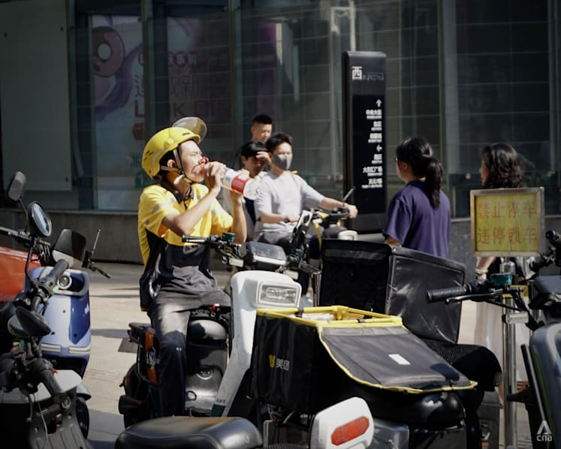
A Meituan delivery rider drinks water while sitting on his scooter in Shenzhen’s Futian district on Oct 13, 2026. (Photo: CNA/Melody Chan)

For delivery riders, these systems determine which orders they receive, how quickly they must complete them and how their performance is assessed.

Failing to meet delivery deadlines or other performance targets can result in penalties, including reduced bonuses or restrictions on receiving new orders.

Decisions to stop assigning orders or suspend accounts would require human review, rather than being left solely to automated systems.

China has previously issued guidelines to protect gig workers, including in 2021 and 2024.

Chinese authorities said the latest proposals aim to extend labour protections to more gig workers, clarify the responsibilities of companies and better reflect the way platform workers are employed.

"The draft … does not establish an entirely new set of workers' rights," said Ou Lin, an employment law lecturer at Lancaster University in Britain.

"Rather, it seeks to transform some existing protective requirements into more legally binding obligations,” she told CNA.

DIFFERENT GIGS, DIFFERENT REALITIES
Delivery riders CNA spoke to in Shenzhen painted a mixed picture of working conditions.

Yang Yuhao, 24, had yet to take a day off more than 20 days into his new job as a food delivery rider.

His delivery station, a local hub that manages riders and their shifts, is run by a contractor for Chinese food delivery giant Meituan. It allows riders four days off a month but decides when they can take them.

When Yang requested a day off, he was assigned another date instead.

"You can't arrange your rest days as you wish," he said, describing the arrangement as having "no freedom to rest".

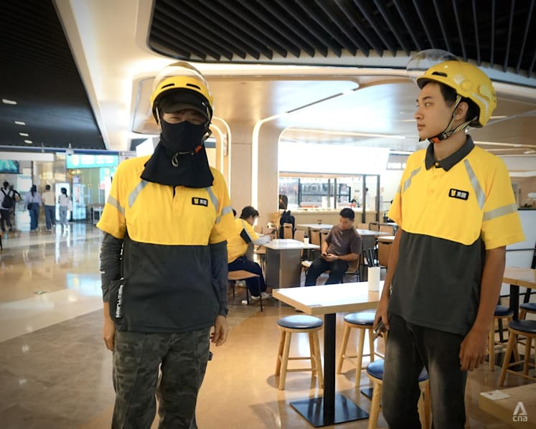
Meituan delivery rider Yang Yuhao, 24 (left), prepares to resume work after a break at a mall in Shenzhen’s Futian district on Oct 12, 2026. (Photo: CNA/Melody Chan)

Delivery deadlines add to the pressure, with riders often held up by traffic lights, lifts, restrictions on entering residential compounds or delays at restaurants.

"Sometimes they assign you several orders to deliver within 40 minutes," Yang said.

Customer complaints can lead to deductions of around 200 yuan, he said, while late deliveries can also affect riders' bonuses.

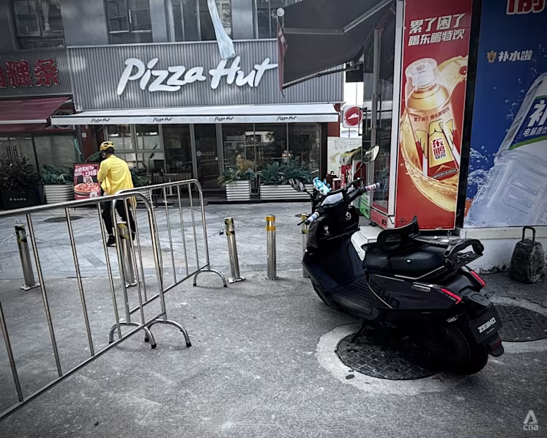
A Meituan delivery rider parks his scooter outside a restricted residential area before making a delivery in Nanshan, Shenzhen, on Oct 15, 2026. (Photo: CNA/Melody Chan)

Other riders have more control over their schedules, but that flexibility can come with fewer protections.

At around 2.30pm in Futian, Shenzhen’s business district, Meituan food delivery rider Wang sat chatting in his own clothes as fellow riders in yellow uniforms hurried off to make deliveries.

The 42-year-old works as a crowdsourced rider rather than following a delivery station's roster.

Unlike riders assigned to delivery stations, crowdsourced riders are typically not formally employed by the platforms. They are paid per delivery and can work across multiple apps.

"I work whenever I want," he said.

Wang said he earns around 5,000 to 6,000 yuan a month, below the roughly 7,000 yuan average for high-frequency riders on scheduled shifts, according to a 2025 survey by Zhejiang University researchers. But he prefers having control over his time.

Wang said he does not receive social insurance contributions, such as those for pension and medical coverage, through his work.

"You're not a regular employee, so you're not protected by the company," he said.


Crowdsourced delivery rider Wang shows the apps he uses to accept delivery orders in Shenzhen on Oct 12, 2026. (Photo: CNA/Melody Chan)

Crowdsourced riders accounted for 71.5 per cent of Meituan's monthly active riders in 2024, according to the company's 2024-2025 rider report.

Lancaster University's Ou said the proposed rules would extend basic protections to workers without formal employment relationships, including requiring written working agreements. But they would not necessarily receive the same social insurance entitlements as regular employees.

MAKING THE RULES COUNT
The proposed rules are open for public consultation until Nov 8 and could still be revised, with no implementation date announced.

Analysts said several challenges remain before the measures can translate into meaningful improvements for gig workers.

Policies must account for the different ways platform workers organise their work, said Li Jia, dean of the School of Economics at Singapore Management University (SMU).

"Policy design needs to strike a balance between protecting workers' safety and preserving their autonomy," he told CNA.

Policymakers must also consider the financial pressures that can make taking time off difficult, he added.

"Meaningful rest rights mean not only that workers can choose to rest, but also that they do not have to sacrifice their health and safety to maintain a basic income," he said.

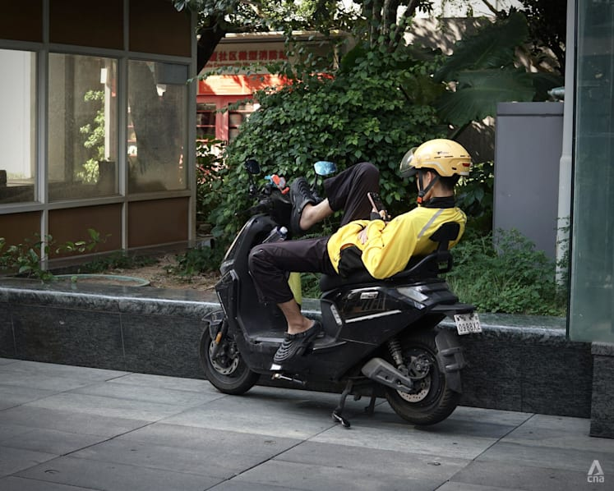
A Meituan delivery rider rests on his scooter while looking at his phone in Shenzhen’s Futian district on Oct 13, 2026. (Photo: CNA/Melody Chan)

Enforcing the rules could prove difficult too.

Lancaster University’s Ou noted that some requirements in the draft do not specify penalties for companies that fail to comply.

While the proposals would give workers access to their work records and complaint procedures, challenging companies could remain tough.

"Their effectiveness will depend on whether enterprises provide complete and accurate information," she said.

Another challenge is determining who bears responsibility when platforms outsource work to contractors.

Yang, for example, works at a delivery station run by a contractor, even though Meituan’s systems influence how his orders are assigned and assessed.

Li said platforms should still be held accountable for riders' working conditions.

"Whoever controls the work process and can influence the risks should bear responsibility in proportion to that control," he said.

Ou warned that platforms could shift responsibilities onto contractors, potentially allowing them to avoid their obligations.

Jenny Chan, an associate professor of sociology at Hong Kong Polytechnic University, said workers need more support to exercise their rights, including from Chinese trade unions.

"When workers are empowered to take matters into their own hands, they can enforce the law," she said.

Source: CNA/mc(ws)

