CAREERS

Chinese millennials and Gen Zers have had enough of work, so they're embracing 'naked resignations'

Alexandra Bacon and Cheryl Teh

Jul 6, 2024

Business Insider

https://www.businessinsider.com/chinese-millennials-gen-z-naked-resignation-loud-quitting-gap-years-2024-7
Alexandra Bacon and Cheryl Teh
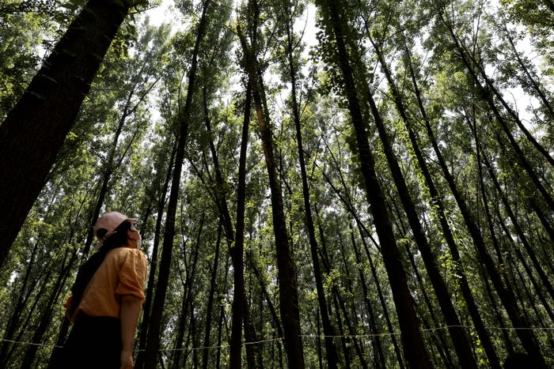
This feeling of monotony and overwork has inspired unsatisfied workers to push back, one expert said.
Zhang Yuan/China News Service/VCG via Getty Images

- Young professionals in China are sharing their "naked resignations" on social media.
- The term refers to quitting your job without having another one lined up.
- Younger people in China appear to be more open to taking time out of their careers to travel.

Gap years haven't traditionally been the norm in China.

Taking a year off work to travel and explore new passions isn't necessarily associated with a fast climb up the career ladder or the pay scale.

But in recent years, young professionals in China have been more willing to share their struggles dealing with long hours and poor pay on social media. The facade of corporate life seems to be lifting as people come to terms with the reality of working exhausting hours without time for themselves.

For more young people, the ultimate luxury is to take time off to escape the grind.

'Naked resignation'
One popular phrase on Chinese social media is "两点一线," which translates to "two points, one line." It refers to the endless commute from home to work and back again without the opportunity to see anything new, Jack Porteous of China-focused consultancy firm Tong Global told Business Insider.

This feeling of monotony and overwork has inspired unsatisfied workers to push back and start videos online of themselves "loud quitting" — publicly sharing news of quitting your job on social media to explore China or further afield for a period of time, Porteous said.

It's a trend similar to the QuitTok social media trend in the West, where China's young workers aren't being shy about resigning from their jobs.

And discussion is rife on Chinese social media about 裸辞 — a term that translates, quite literally, to "naked resignation." And it means just that — quitting one's job without a backup plan to rely on.

Take, for instance, a viral post penned by a 28-year-old on Weibo, China's version of Twitter. The person, who wrote the post on July 5 under a pseudonym, said they resigned without a backup plan right after getting a raise because they wanted to "stop for a while."

"In the last two years, my pay has risen once every half year, but I always thought that the most important thing in my life shouldn't be work," read the post. Business Insider was unable to verify the identity of the social media user.

The post's author also lined up a bucket list of what they intended to do after leaving their job — learning English, getting fit, becoming a better cook, and going on a trip to "see all the great scenery I never had the time to see."

"I don't know if my life will be better after this 'naked resignation.' But I think that if I stay the same, then the things that I don't dare to do at 28 will become things that my older self would simply never attempt," the person wrote. "Life is short. There's no time like the present."

It isn't just this one person who has "naked resignation" on the brain. Weibo is also chock-a-block with trending topics — akin to hashtags — expanding on the topic. Examples seen in BI's search of the keyword included "how much to save before naked resignation," "three things to consider before naked resignation," and "20 jobs to try after naked resignation."

Over on Xiaohongshu, a platform akin to Instagram, people also post stories of their lives after "naked resignation." Some posts detail the pros and cons of "naked resignation." Others read like travel diaries, advocating for a slower, more fulfilling life outside the corporate rat race.

Taking a career break

Young people are using their gap years to spend more time outdoors reconnecting with nature. Costfoto/Future Publishing via Getty Images

Porteous told BI that some people are taking the opportunity to spend quality time with family and visit parts of China they never had the opportunity to explore.

He added that activities related to crafting and spending time outdoors have been especially popular with those looking to learn a new skill or reconnect with nature.

A gap year is also an opportunity to visit somewhere outside the traditional bucket list destinations like big cities in Europe.

"There is a preference for niche destinations and unique experiences, aiming to escape reality and immerse themselves in authentic local cultures," Laurence Lim, founder and managing director of branding agency Cherry Blossoms Intercultural Branding, told BI.

For younger people, gap years can allow for personal growth and exploration often before they embark on their careers.

"They want to travel, learn new skills, or engage in volunteer work before committing to long-term career paths," Sally Maier-Yip, the founder of China-focused communications consultancy 11K Consulting, told BI.

"A gap year can provide a much-needed break and help young people enter the workforce more refreshed and motivated," she said.

China's tough work culture and economic downturn
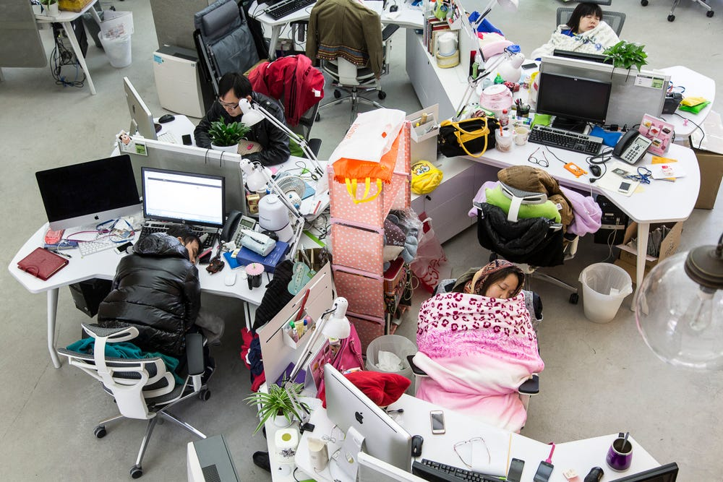
China's tech industry is notorious for its grueling "996" work culture. Qilai Shen/In Pictures Ltd./Corbis via Getty Images
It's no secret that China's job market has been less than favorable for its young graduates and early career professionals.
According to the National Bureau of Statistics of China, the unemployment rate of people aged 16 to 24 was 14.9% in December, compared to 6.1% for those aged 25 to 29 and 3.9% for those between 30 and 59.
The recent economic downturn and the pandemic have led many young people to rethink their careers and try to find new meaning in their lives.
Viral social media trends like "lying flat" are examples of this disillusionment with work, Lim told BI. "It reflects a shift away from traditional definitions of success, focusing instead on freedom, happiness, and health rather than career achievements," she said.
And many of those opting to take gap years come from the tech sector, Porteous said.
It's an industry notorious for the highly competitive "996" work culture," which demands workers clock in from 9 a.m. to 9 p.m. six days a week.
Alibaba CEO Jack Ma once endorsed the grueling schedule, calling it a "huge blessing" for young professionals. Qu Jing, a former PR lead at Chinese tech giant Baidu, stepped down earlier this year after posting videos online ripping into staff who disagreed with her extreme approach to work.
"Finding a decent job in big techs is a dream shared by young aspirants from elite universities," Jenny Chan, an associate professor of sociology at The Hong Kong Polytechnic University, told BI. But succeeding in China's tough tech industry requires full devotion of time and effort, which blurs the boundaries between work and home, she said.
The economic turndown and tough work culture can leave people feeling like mere cogs in the machine of larger corporations, Lim told BI. "They are often disillusioned and demotivated."

Generational divides
With the help of social media, the younger generations are more inclined to question the status quo regarding careers. But older generations haven't felt so favorably about taking time out of work.
"Older Chinese generations are generally suspicious of the concept of gap years," Lim told BI.
"There are articles on Chinese social media criticizing gap years," she said, "arguing that it is a Western concept that does not adapt well to Chinese society."
She said older generations may see it as a hindrance to career progression, while Gen Z is perhaps more open to prioritizing self-awareness and self-care.
"There's a popular internet buzzword among Chinese young people, "Gai溜子," which can be roughly translated to "drifter" on the street," Lim added.
It's a term used to poke fun at themselves for not having a plan and wandering through life. "It reflects a laid-back attitude where they're proud to step back from the traditional hustle and simply enjoy life", she said.

Copyright © 2024 Insider Inc. All rights reserved. Registration on or use of this site constitutes acceptance of our Terms of Service and Privacy Policy.

